GALLERY OF SCREEN CAPTURES

SHARK CAGE 3D

The **“Shark Cage 3D”** is a three dimensional interactive game between the player and the shark. Includes, so many features represented in several screenshots for better understanding.

* The game field is a meshed **“Cube”**. The player is at the center of the cube at the origin and can move in all the direction to shoot the randomly moving shark.

The player is at the center of the cube and can shoot the shark with the help of the red bullet which is indicated at the screenshot.

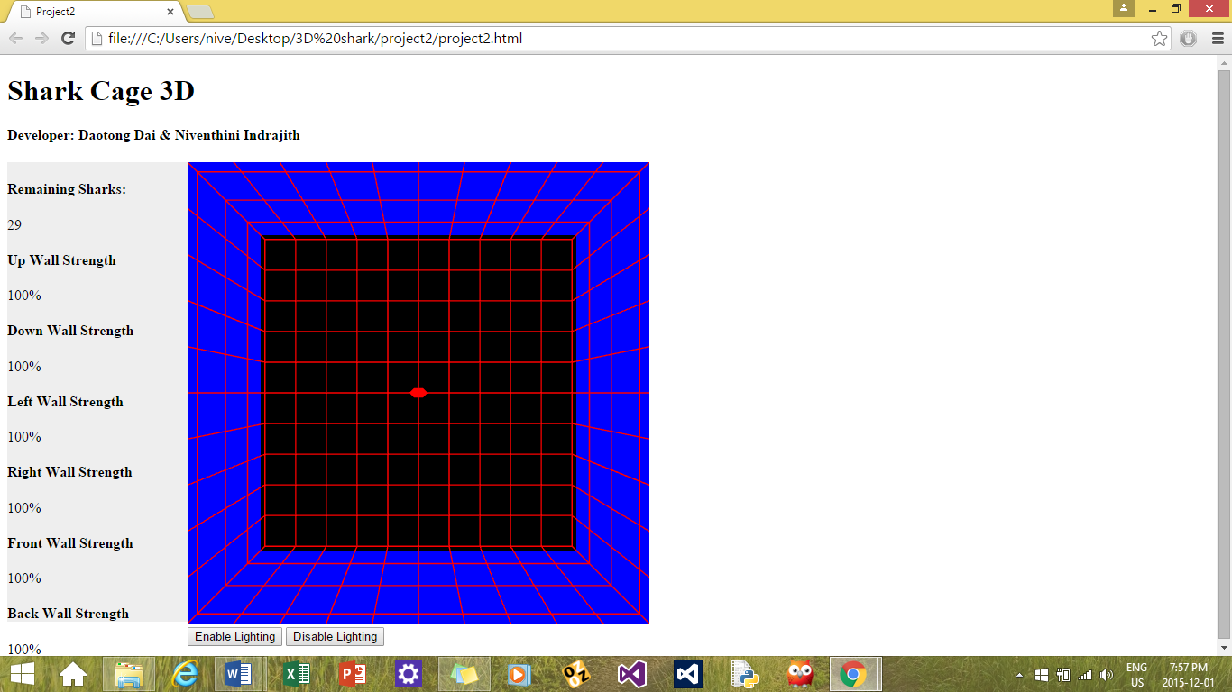

* The player can move in all the directions (6 sides of the cube) to shoot the randomly moving shark.

The player field starts as a cube with the player at the center and the shark is in front of him,

with an intention to chew the meshed cage.

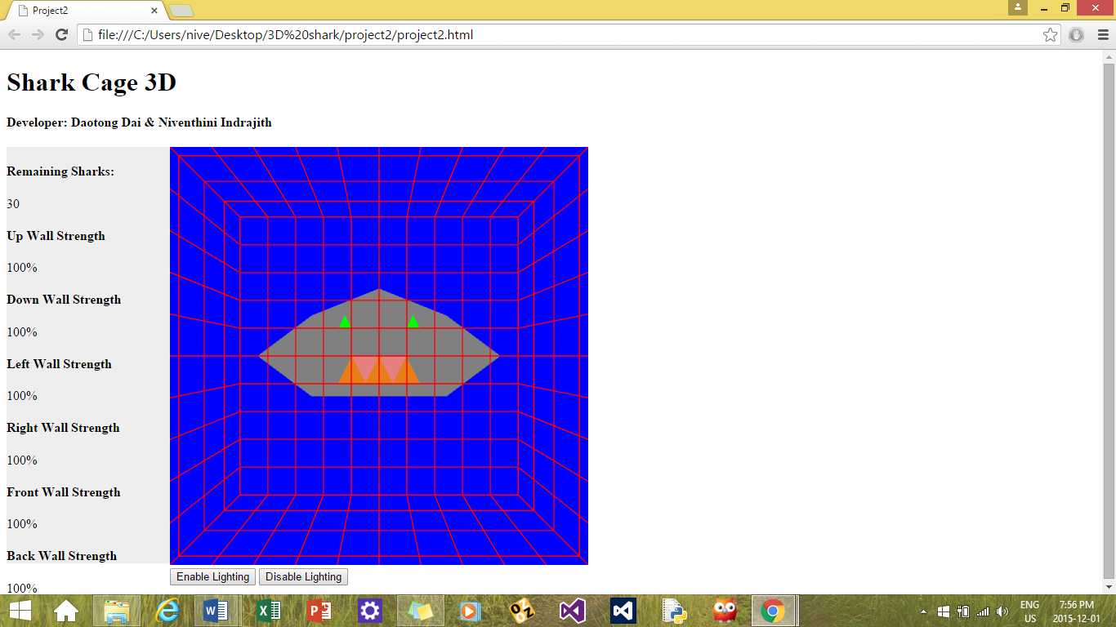

* The player who is at the origin can make a smooth rotation to all the direction, with the help of the keyboard arrow keys (Up, Down, Right and Left) and the player can shoot in the facing direction.

The player facing the shark which is at the left outside the cube and can shoot the shark. This shows the smooth rotation.

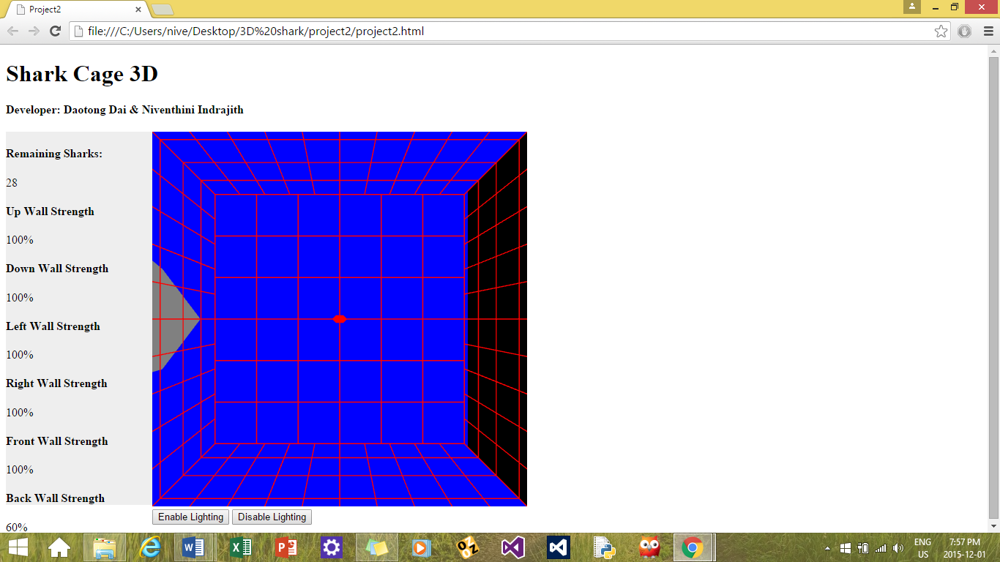

* The shark appears randomly at one of the side of the cube whenever the player is trying to shoot it.
* The player changes his direction by facing towards each and every side of the cube to face the shark directly and shoots it. Meanwhile the shark starts to chew, part of the cube.
* The player shoots as quickly as possible to drive the shark away.

The player is facing towards the shark which the shark is at the **“left”** side of the cube cage.

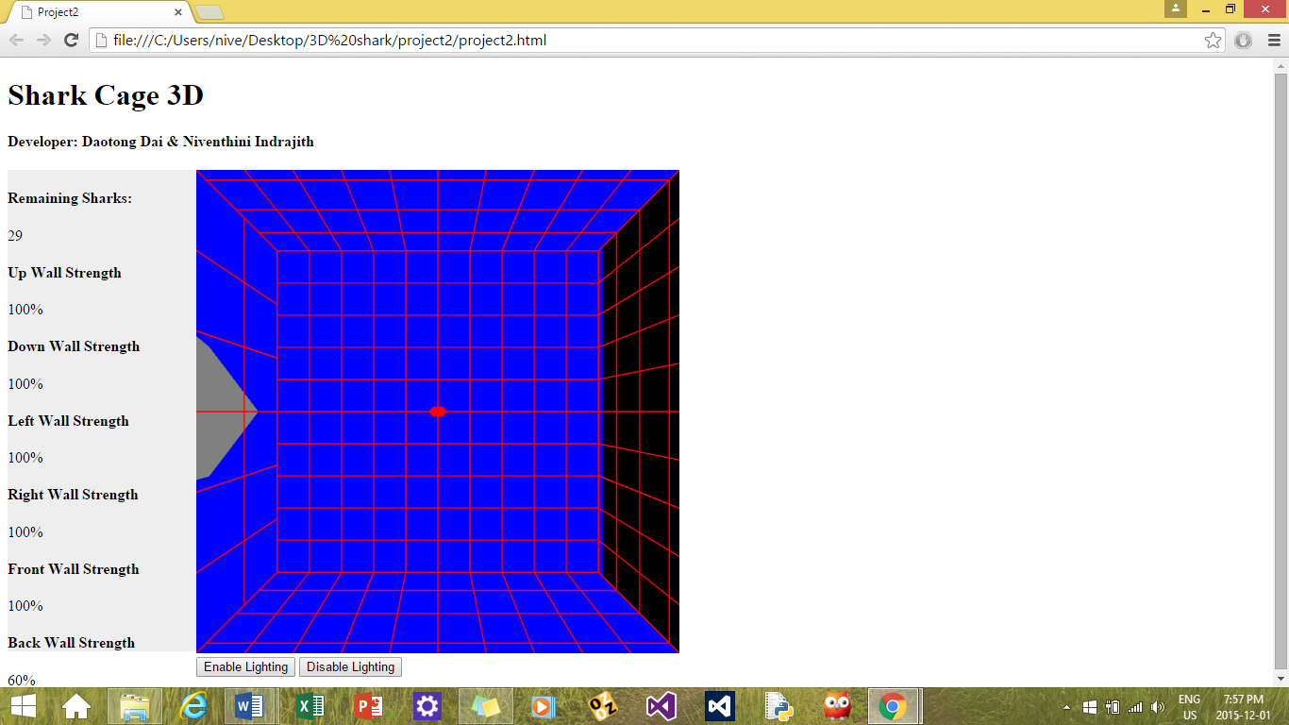

The player is facing towards the shark in the **“right”** side of the cube in an intention to shoot the shark

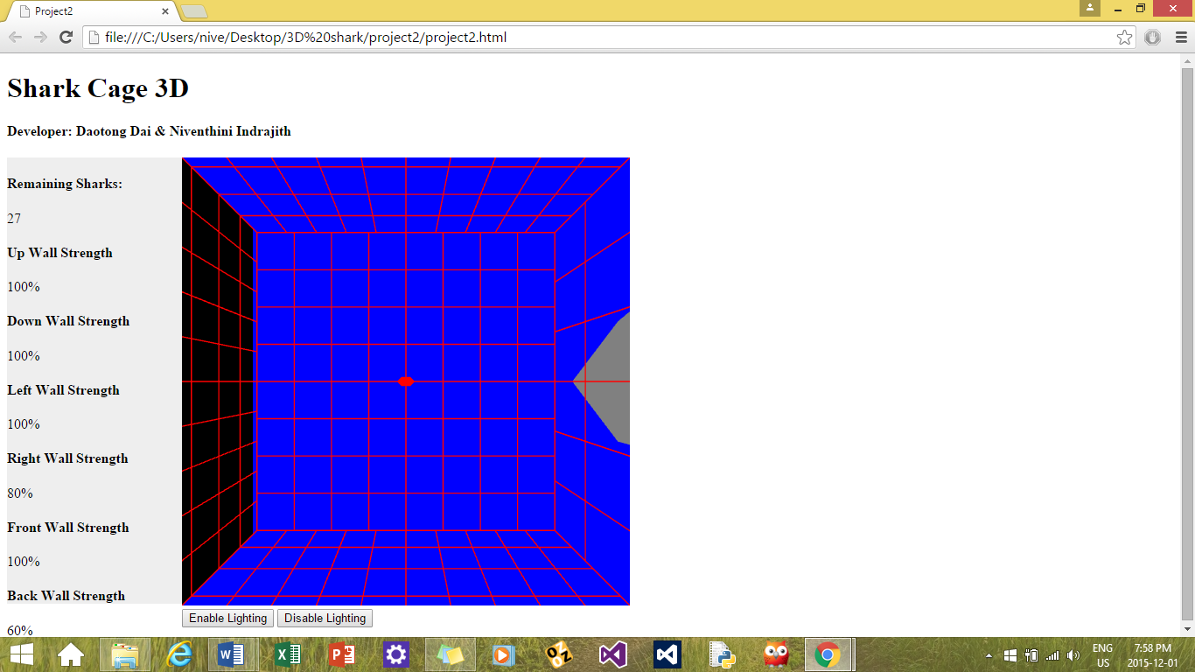

The shark is at the **“top”** of the cube and player try to shoot the shark facing it

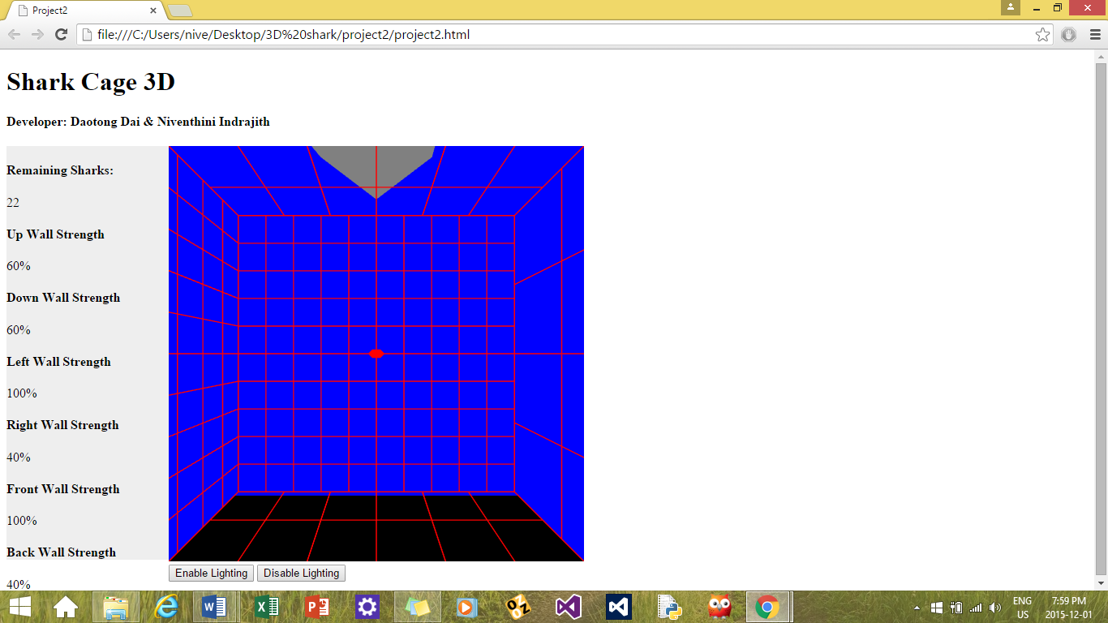

The shark is at the **“bottom”** of the cube cage and the player is facing it.

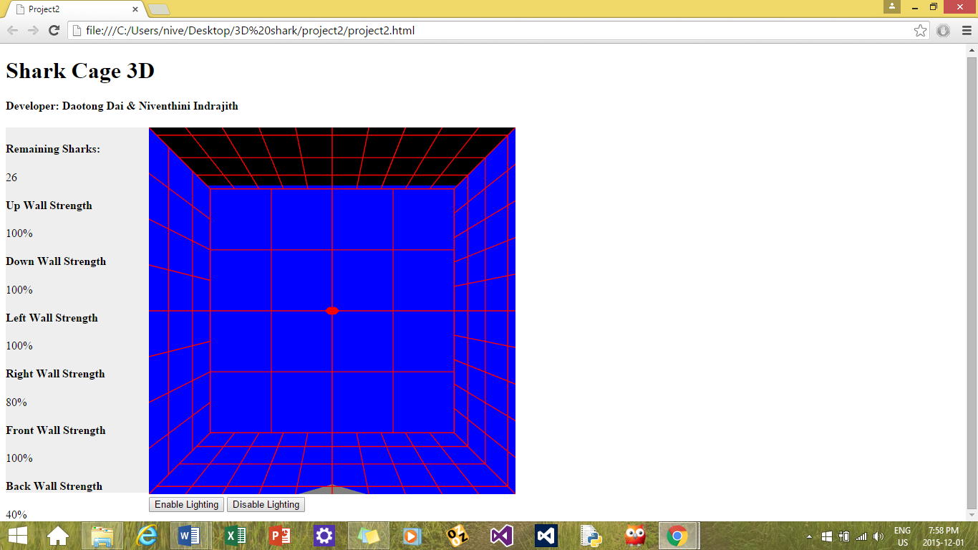

The shark is at the **“front”** side and chewing the cube cage.

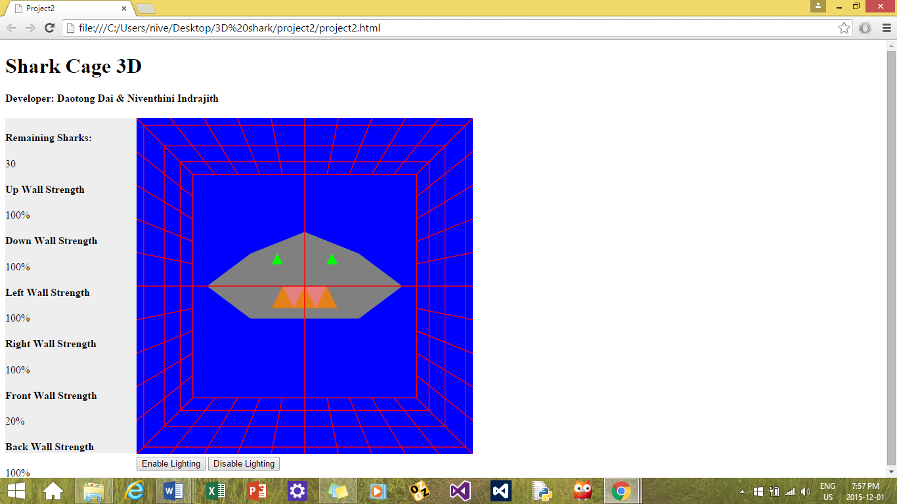

The shark is at the **“back”** side of the cube cage

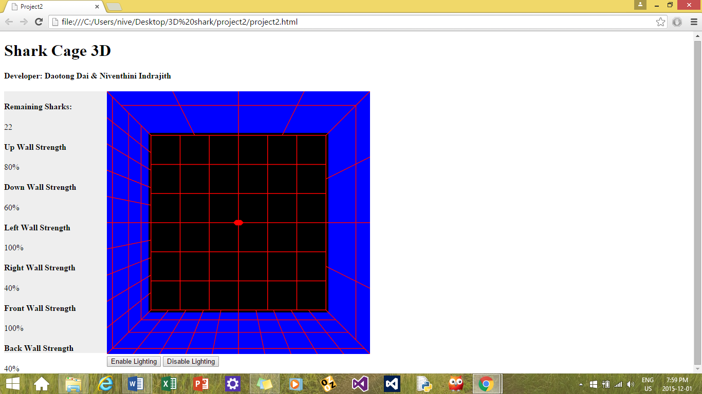

* Whenever the shark chews a part of the cage the **“Strength Measure”** is shown on the left side of the player field on the screen.

The strength measure of the front wall is 40% as the shark chewed it

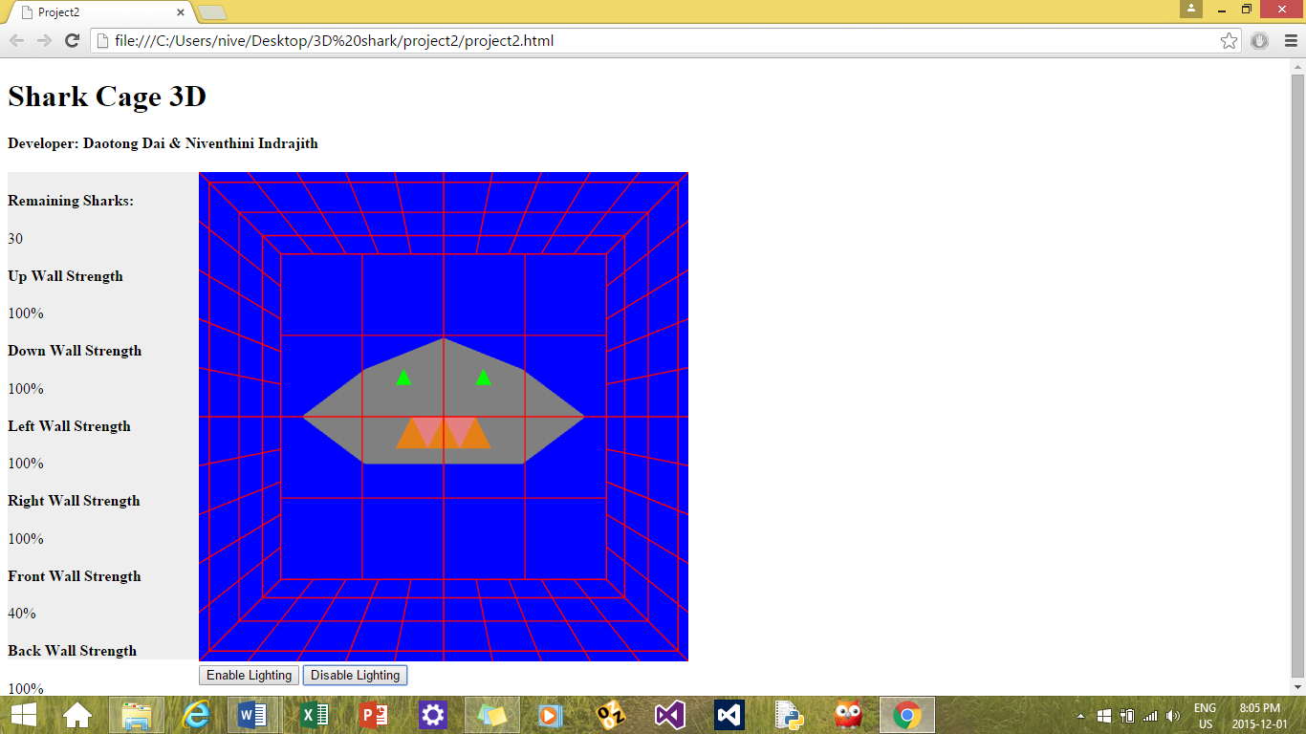

* When a side is completely chewed away the shark wins and the message is delivered as **“You Lose”**

The shark completely chews the front part of the cage and the strength measure of the front wall appears to be 0% and the **Shark Wins!!!**

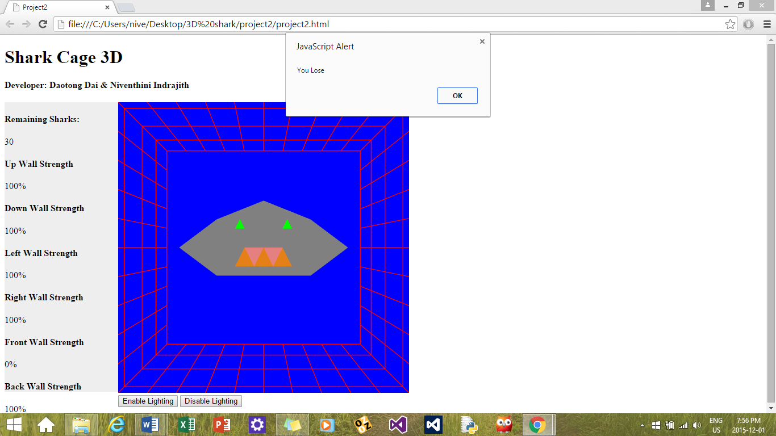

* If the player shoots complete number of 30 Sharks then the **“you win”** the game

The player shoots 30 shark, indicates to be 0 on the left side of the screen then **“Player Wins”**

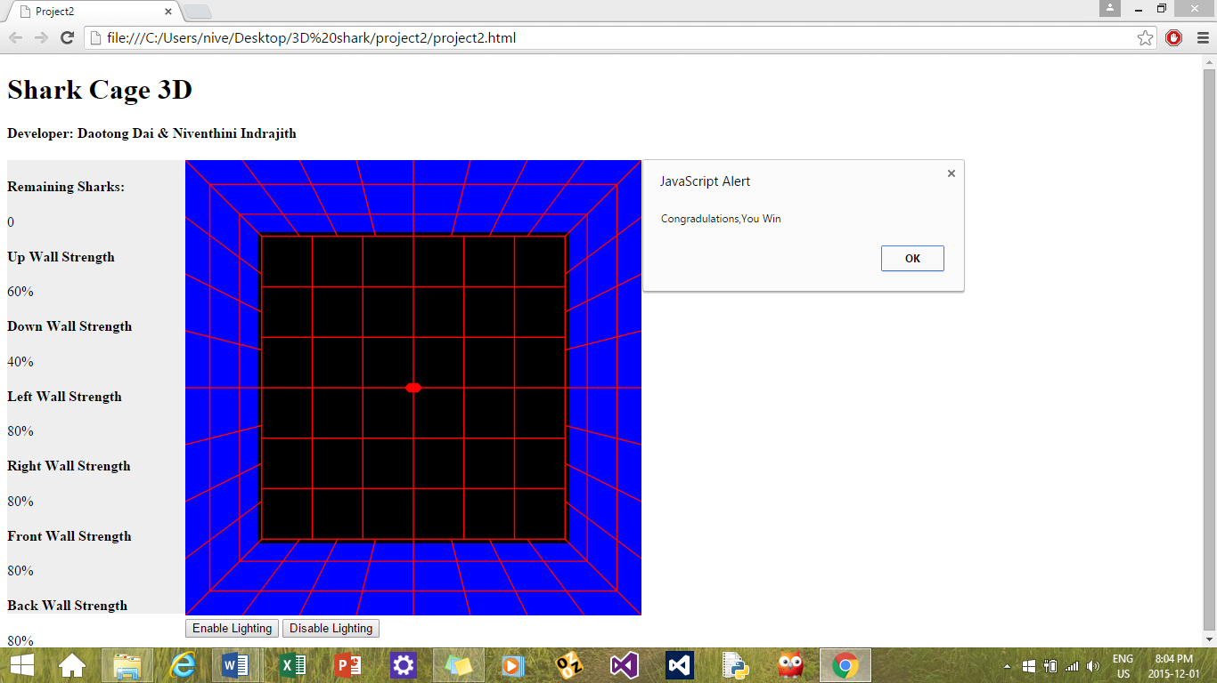

* When the shark appears on each and every side of the cage then this indicated by the **shadow,** change of black color on the opposite side of the cube.

The shark is at the left side of the cage and the shadow is indicated with the black shadow on the opposite of the cage.

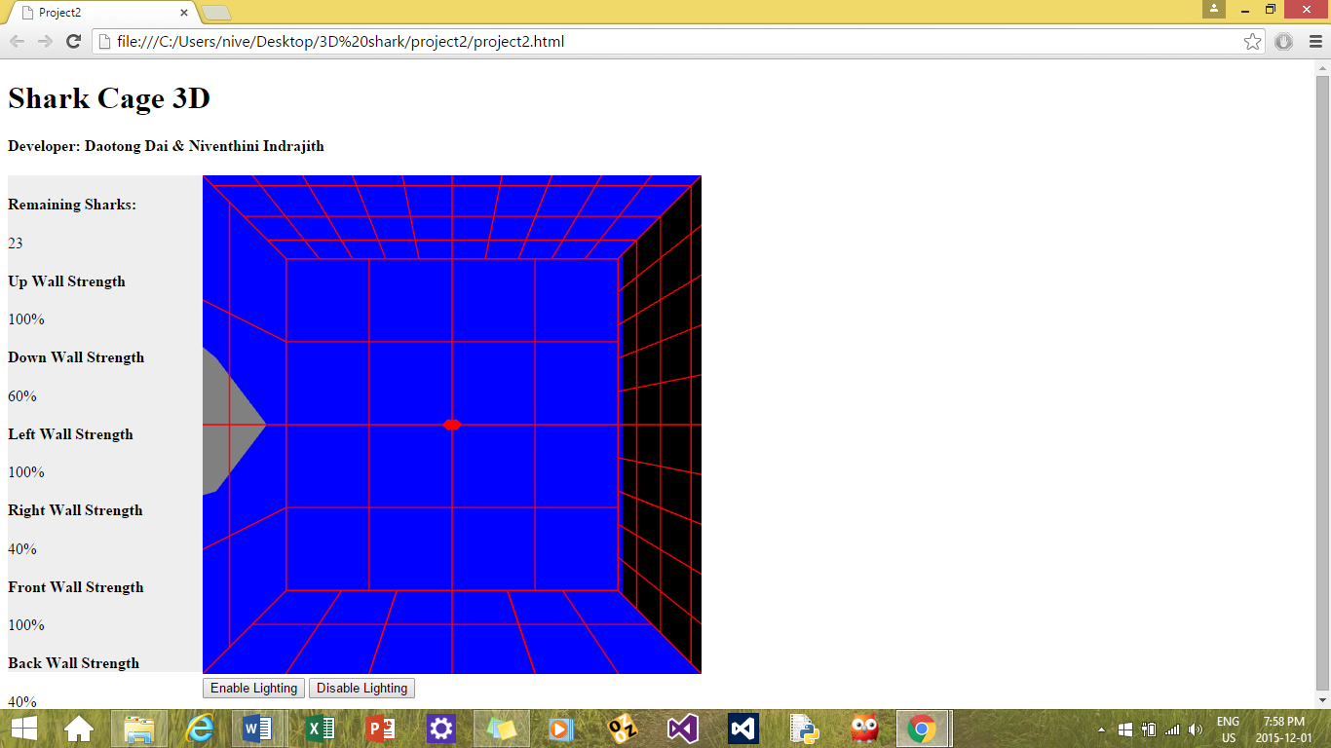

* Player is able to view the play field viewing one side of cube with enough peripheral vision to see the bit of the adjacent side of the cage which are visible.

A bit of all the adjacent sides of the cube cage is visible to the player

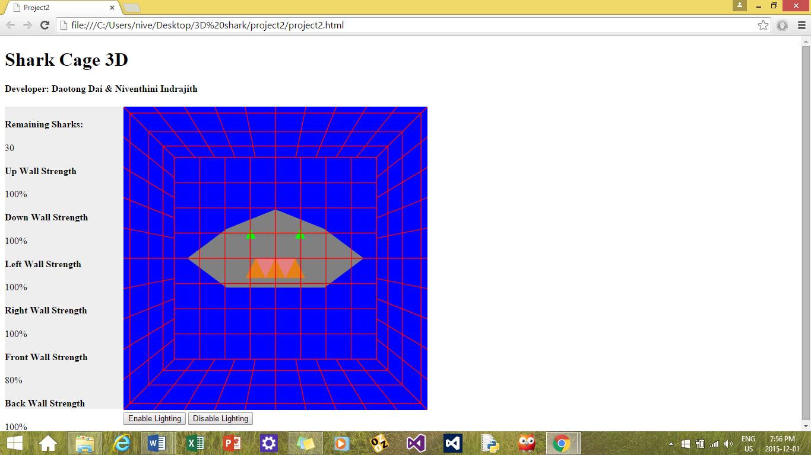

**ADDITIONAL FEATURES :**

All the additional features have been implemented in this three dimensional game to have more attractions

* The shark can move randomly in all the six sides to chew the part of the meshed cube and this is indicated to the player by the shadow (black color) in the all the opposite sides of the cube.

The player is facing towards the shark which the shark is at the **“left”** side of the cube cage.

FEATURE 1 : (Shark moves in all the six sides and the shadow is shown on the opposite side)

The shark is at the **“left”** and the shadow is shown on the right



The shark is at the **“right”** and the shadow is shown on the left



The shark is at the **“top”** and the shadow is shown down



The shark is at the **“bottom”** and the shadow is shown on the top



The shark is at the **“front”** and there is no shadow is shown



The shark is behind the player and the shadow is shown front



* The playing field is a **“meshed cube”.** Whenever the shark chews a part of the cage the cage is shown with the partially decreasing mesh cube.

FEATURE 2 : (The mesh cage becomes sparse whenever the shark chews it)

The shark chews the front wall of the cage and the strength of the wall becomes **60%**

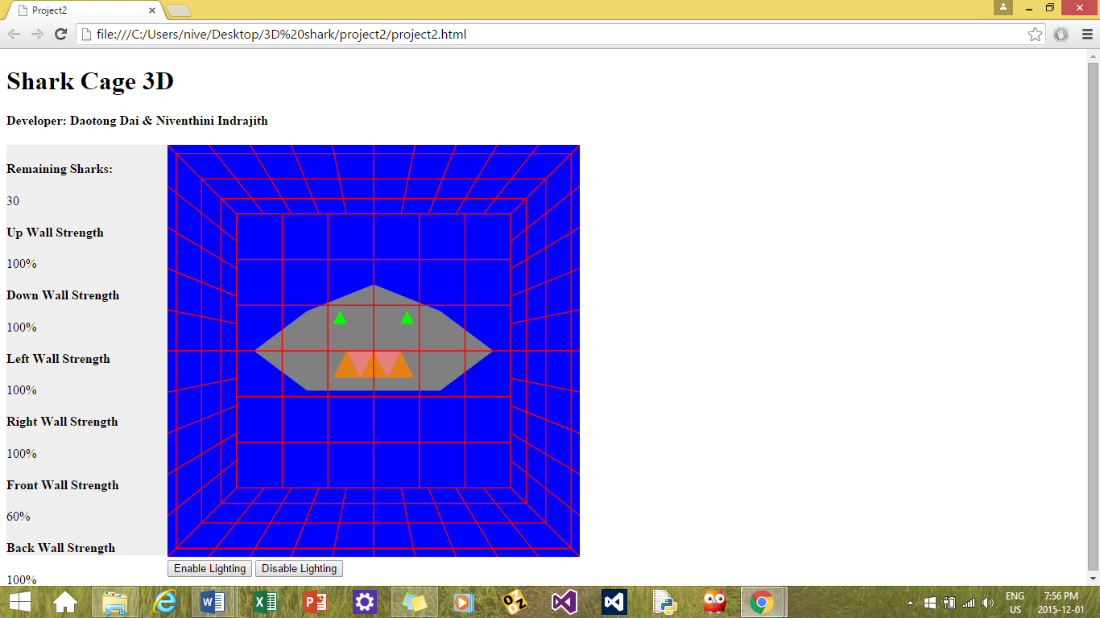

The strength of the front wall is **40%** now….

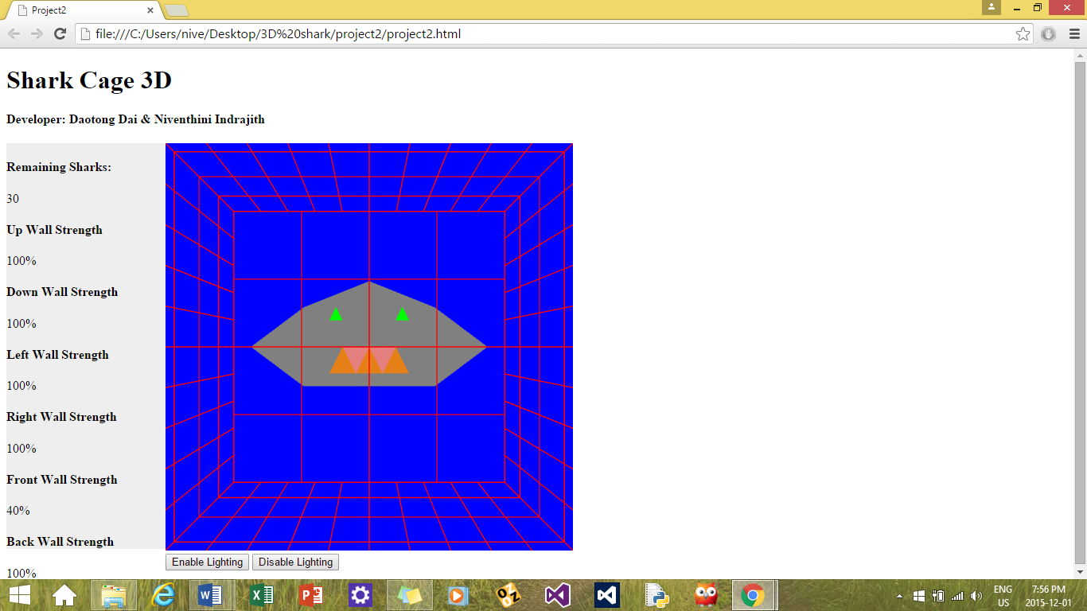

The strength of the wall is **20%** now…



The strength of the front wall turns to be **0%** as the shark chewed the part completely and the shark wins the game.



* The lighting is used and this is indicated by the enable lighting and disable lighting GUI controls

FEATURE 3 : (Lighting)

There are two GUI controls buttons named “Enable lighting” and “Disable lighting” is shown at the bottom of the screen and can controlled by the user’s wish.

This shows an enabled lighting.

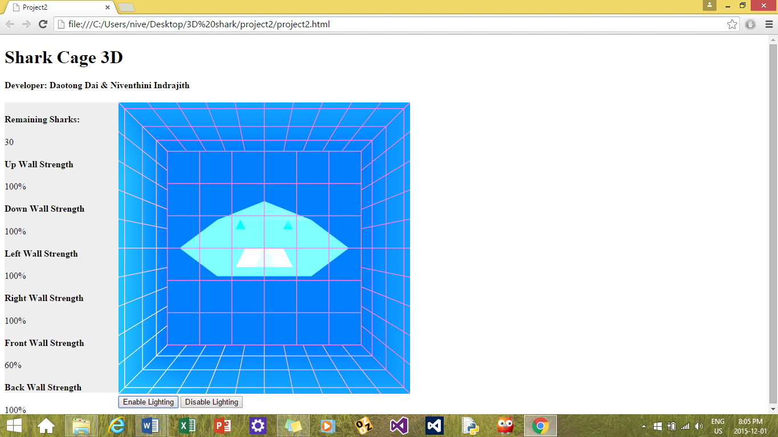

CONCLUSION :

All the basic and additional features have been implemented in this **“Shark Cage 3D”** game.